Analysis of Covid-19 data

**From 22-01-2020 to 23-09-2020**

General Analysis of Confirmed, Deaths and Recovered cases:-

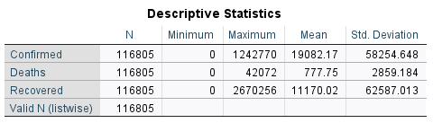

***Analysis of worldwide confirmation of Covid-cases over time***

***Daily increase in confirmed cases over a period of time***

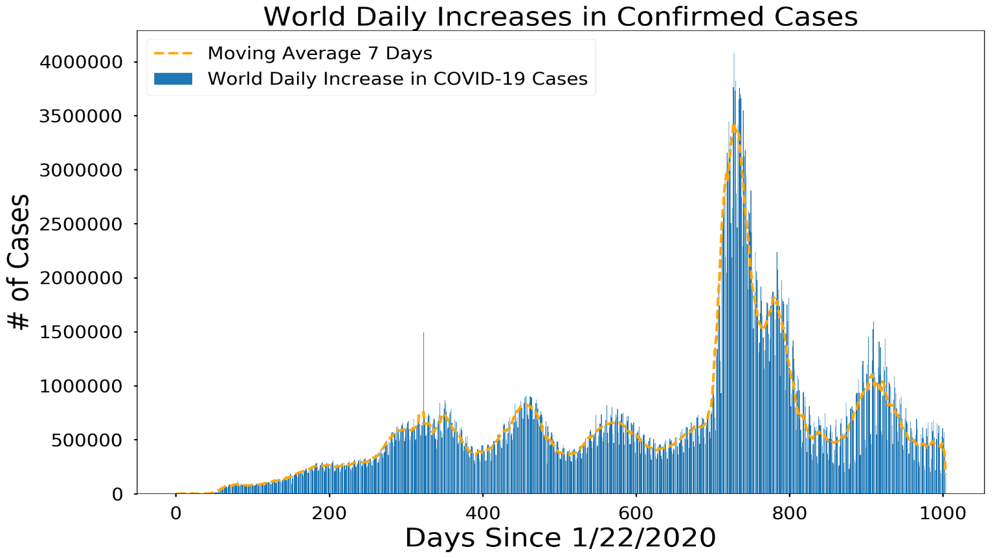

***Deaths from Covid-19 over time (worldwide)***

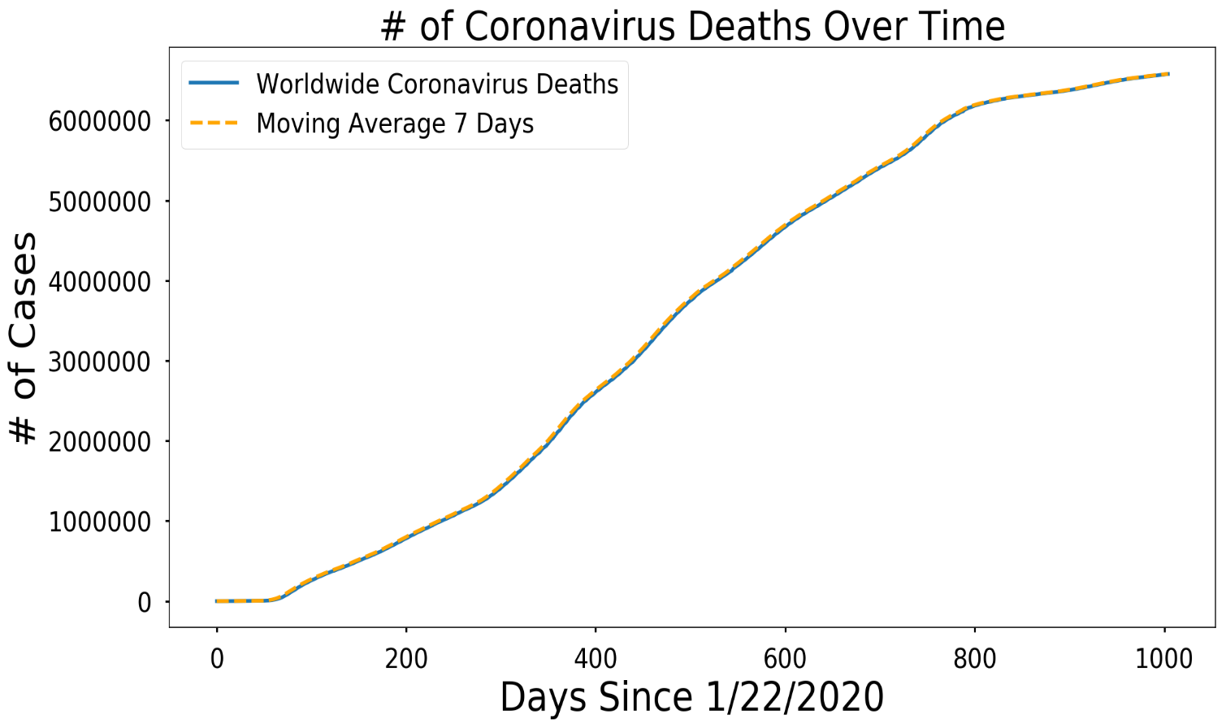

***World daily increases in deaths from Covid***

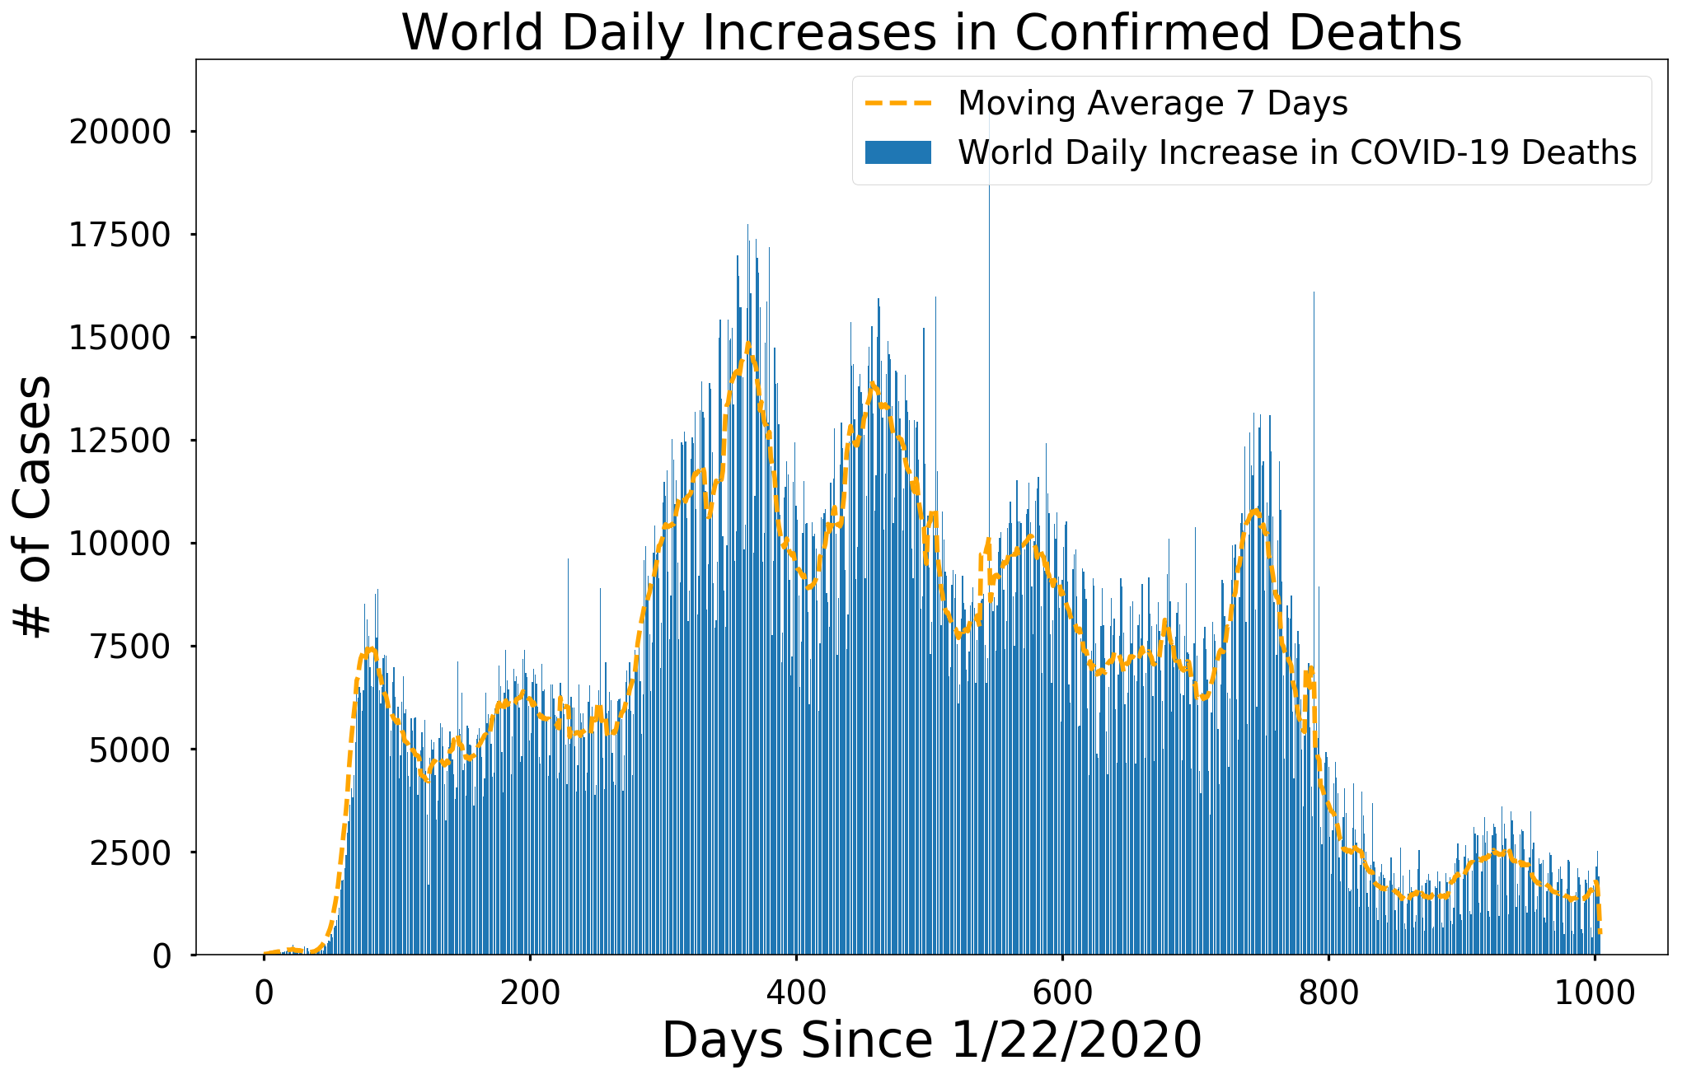

***10 MOST AFFECTED COUNTRIES OF COVID-19***

*Pie representation of Cases confirmed by each country*

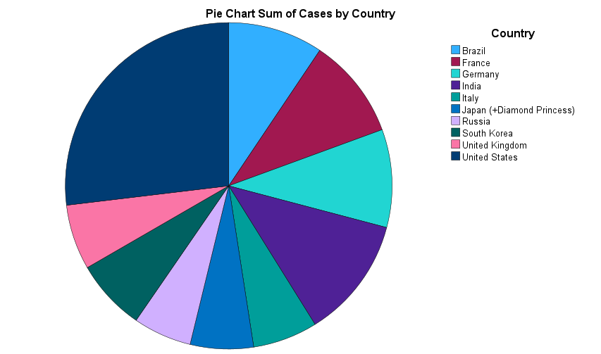

*Pie representation of Deaths in each country*

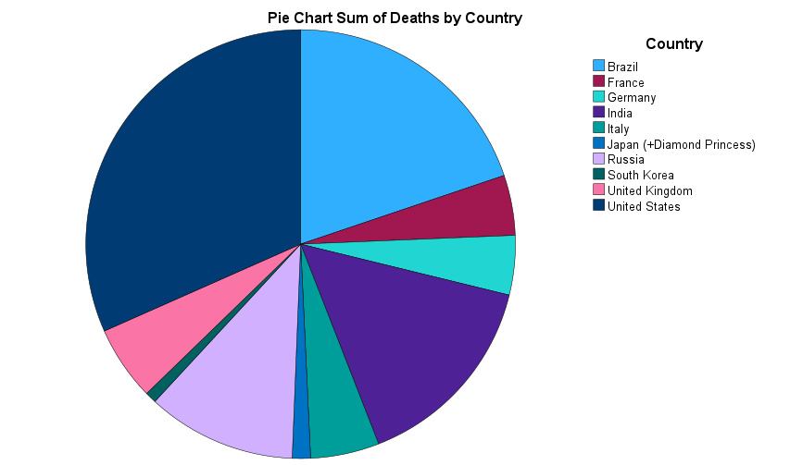

***Most affected regions of the world***

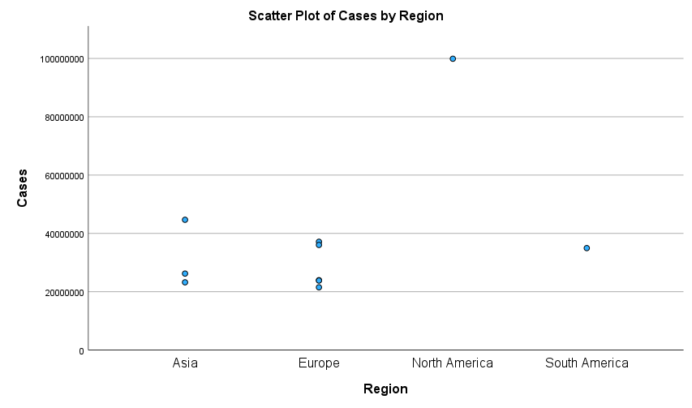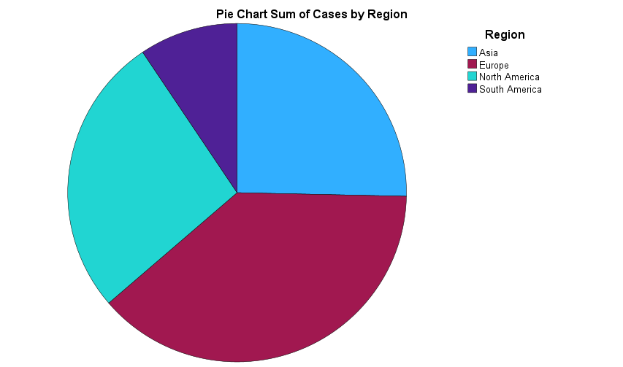

***Deaths Region-wise***

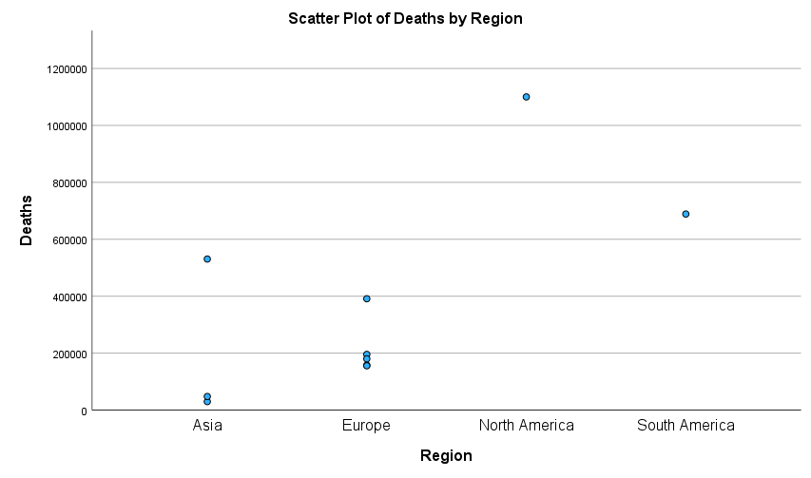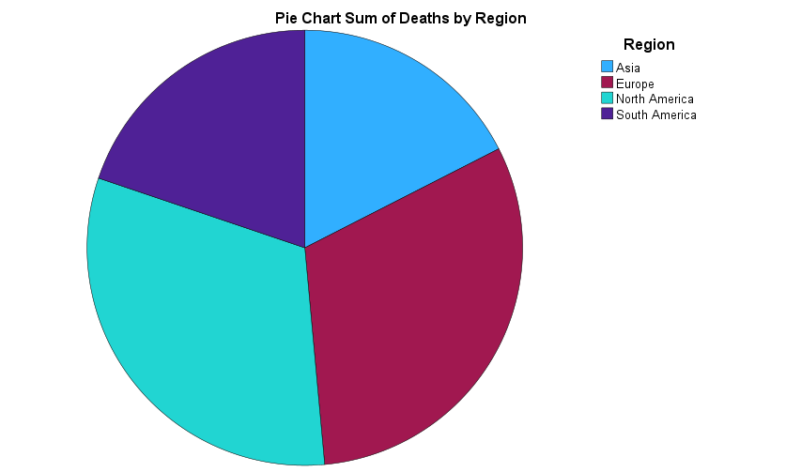

***Boxplot of deaths***

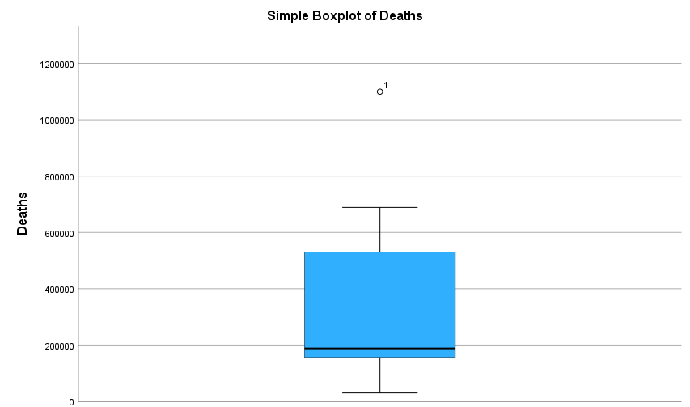

***We can observe that we have one outlier. The outlier represents the number of deaths in the United States. United Stated reported greatest number of deaths due to Covid-19 in the world.***

***Bar chart for cases in top 10 most affected countries***

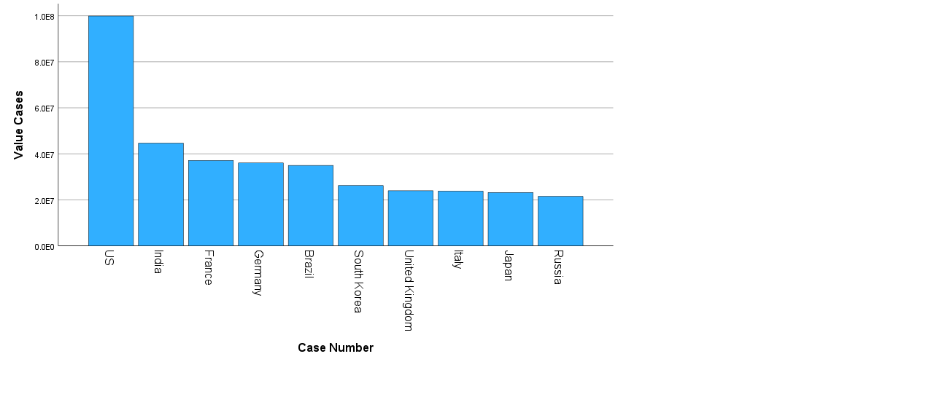

***Bar chart for deaths in top 10 most affected countries***

